Retinal Disease Classification using Deep Learning
[1] Riya Chandrakar, [1] Dr. P Balamurugan
[1]: Department of Networking and Communications, School of Computing,
SRM Institute of Science and Technology Kattankulathur - 603 203
rc1425@srmist.edu.in,balamurp@srmist.edu.in

Abstract—Early detection of eye diseases such as Cataract, Glaucoma, and Diabetic Retinopathy is crucial for preventing vision loss and ensuring timely treatment. In this work, a Deep Learning–based Computer Vision model is developed to automatically classify retinal fundus images into four categories, Cataract, Glaucoma, Diabetic Retinopathy, and Normal. The​‍​‌‍​‍‌​‍​‌‍​‍‌ model training and testing is based on the publicly available Eye Diseases Classification Dataset from Kaggle, which is a collection of retinal images labeled for each disease class. Feature extraction and classification are done through a VGG19 Convolutional Neural Network (CNN) architecture, which has been confirmed to be efficient in medical image analysis. The system is built with TensorFlow and Keras, and the model is said to have attained an overall accuracy of 89%, thus it made high precision and recall most of the time for all classes. The findings show that deep CNNs are capable of extracting discriminative visual features from retinal images, thus they can be considered as a reliable method for the automated eye disease screening. The present research serves as a beacon for the use of deep learning in ophthalmology, thus the diagnosis would be faster and more accurate, and the global challenge of preventable blindness would be alleviated.
Keywords—Retinal Fundus Images, Deep Learning, Convolutional Neural Network (CNN), Transfer Learning, Diabetic Retinopathy, Glaucoma, Cataract, Image Classification, Medical Image Analysis, Automated ​‍​‌‍​‍‌​‍​‌‍​‍‌Diagnosis

Introduction
Eye​‍​‌‍​‍‌​‍​‌‍​‍‌ diseases like Cataract, Glaucoma, and Diabetic Retinopathy (DR) are some of the primary causes of vision loss and blindness globally. The World Health Organization (WHO) reports that about 2.2 billion people worldwide have visual impairments of various kinds, and at least half of these cases can be prevented or cured if diagnosed early. But the problem is that the manual checking of retinal images by ophthalmologists takes a lot of time, is expensive, and can be incorrect due to human mistakes. In order to remove these barriers, major breakthroughs in Deep Learning (DL) and Computer Vision (CV) technologies in recent years have given a perfect answer to the automation of medical image analysis.
We suggest in this paper a Convolutional Neural Network (CNN)-based method to distinguish the retinal fundus images of four categories i.e. Cataract, Glaucoma, Diabetic Retinopathy, and Normal. The dataset for this work is taken from the Kaggle Eye Diseases Classification Dataset, which is a collection of the retinal images with labels depicting the different diseases. CNN models can do away with the need for manual feature extraction from images as they can on their own learn the hierarchical visual features like color intensity, edge patterns, and texture from the images, thus making them the best choice for medical image classification.
Our model is built around the VGG19 design, which is implemented using the TensorFlow and Keras libraries. The reason for selecting VGG19 is that it is a good deep CNN model and has been proven to perform feature extraction and fine-grained image recognition tasks very well. The model is both trained and tested to attain a collective classification accuracy of 89%, thus it is capable of making detection and differentiation of the multiple retinal issues with a high level of precision. The present study serves as an example of how deep learning can be a game changer in terms of the accuracy and speed of ophthalmic disease diagnosis, which envisages the feasibility of large-scale screening systems along with enhanced patient ​‍​‌‍​‍‌​‍​‌‍​‍‌care.

Related Work
Detecting​‍​‌‍​‍‌​‍​‌‍​‍‌ eye diseases with deep learning is an area that has attracted a lot of attention recently because of the potential it has to make a diagnosis both fast and accurate. Convolutional Neural Networks (CNNs) as well as transfer learning have been largely adopted in the classification of retinal images into diseases like glaucoma, cataract, and diabetic retinopathy. This part is a literature survey of the works done in the field of datasets, methods, and models' performances.
V. Gulshan et al. have created and attested a deep learning algorithm to identify diabetic retinopathy (DR) from retinal fundus photographs, and the results were published in JAMA. This was a pioneering work that showed practical application of CNNs in the automation of disease screening which is done in clinical settings. By using more than 128,000 retinal images that were graded by ophthalmologists, the model was able to achieve both sensitivity and specificity at a level of a professional ophthalmologist, and the AUC for referable DR detection was 0.99 [1].
The work of D. S. Kermany et al. published in Cell, "Identifying Medical Diagnoses and Treatable Diseases by Image-Based Deep Learning" was a breakthrough that illustrated how CNNs can be used for the diagnosis of multiple diseases by analyzing medical images. By using a vast dataset that contained retinal OCT scans and chest X-rays, their model was able to correctly identify diabetic macular edema, choroidal neovascularization, and pneumonia, thus demonstrating the potential of CNNs for various medical imaging fields [2].
D. S. W. Ting et al. came up with a deep learning method for detecting diabetic retinopathy as well as other ocular disorders from the retinal photos of the multiethnic population. Their work, which was published in JAMA, demonstrated that their method was effective across different ethnic groups, thus the model had a strong ability to generalize in actual screening scenarios [3].
S. Ajitha and D. S. P. Kumar have designed a deep learning method for the identification of glaucoma from the images of the fundus, and the results were reported in the journal Scientific Reports. Their CNN-based system was capable of automatically differentiating features in retinal images, and it did not require manual preprocessing. The model was successful in getting high precision and being robust, thus it was able to make clean separation between normal and glaucomatous eyes [4].
In their paper published in Scientific Reports, R. Hemelings and colleagues presented a glaucoma identification strategy using a CNN that analyzed whole retinal images rather than just the optic disc. Their research demonstrated the significance of the outer areas of the retina in providing clues for glaucoma and hence the overall detection accuracy was improved [5].
A. Choudhary set up a retinal disease classification system based on deep learning which utilized the VGG-19 network architecture. The model was adjusted via transfer learning using a public retinal dataset and was able to identify diseases like diabetic retinopathy, glaucoma, and cataract with extremely high precision. The research identified the good performance of transfer learning in the field of medical image analysis where there are few annotated datasets [6].
H. Xie and colleagues, in their paper published in Nature Scientific Reports, presented a CNN-based approach to identify visually impaired cataract caused by retinal images. Their model was an automatic one for the assessment of the cataract severity and it achieved very high precision and recall, at the same time, it was better than the traditional handcrafted feature methods [7].
L. Pascal et al. developed a multi-task deep learning model for detecting glaucoma from color fundus images, which was reported in the journal Scientific Reports. Their model was capable of both glaucoma classification and optic disc segmentation at the same time. The multi-task learning scheme helped the model to become more interpretable and also led to better diagnostic performance due to the shared feature extraction [8].
D. Muthusamy, R. Babu, and S. Ramesh, in their Soft Computing (Springer) article, described the creation of a CNN-based system tailored to the detection of diabetic retinopathy. They enhanced the model with batch normalization and dropout layers for regularization, so it could effectively differentiate various DR stages. Their model was able to surpass the accuracy of traditional image processing methods, thus paving the way for a fully automated DR screening system that is capable of early intervention for patients [9].
S. M. Saqib, K. Mehmood, and H. Ali, in their paper published in Sensors journal, centered their work on transfer learning for the detection of cataract and glaucoma. They used pre-trained CNN models such as ResNet and VGG to accomplish high precision with minimal training data. Their research pointed out the importance of compact, real-time CNN models as a solution for ophthalmic diagnostics in healthcare environments that are poorly resourced ​‍​‌‍​‍‌​‍​‌‍​‍‌[10].

Methodology
The section illustrates the systematic process that was followed in the design and implementation of the Convolutional Neural Network (CNN)-based model for the classification of eye diseases. The presented method through the phases of dataset acquisition, preprocessing, augmentation, model architecture design, training, validation, and evaluation. These phases, individually, hold utmost importance in obtaining the high accuracy of the model and making sure its applicability in the clinical environment.

Dataset Collection
Kaggle's Eye Diseases Classification dataset served as the source for the data utilized in this analysis. The dataset houses the labeled retinal fundus images related to the four classes: Cataract, Glaucoma, Diabetic Retinopathy, and Normal. Each picture offers an in-depth visual of the eye, thus the model can catch the pattern of the disease. 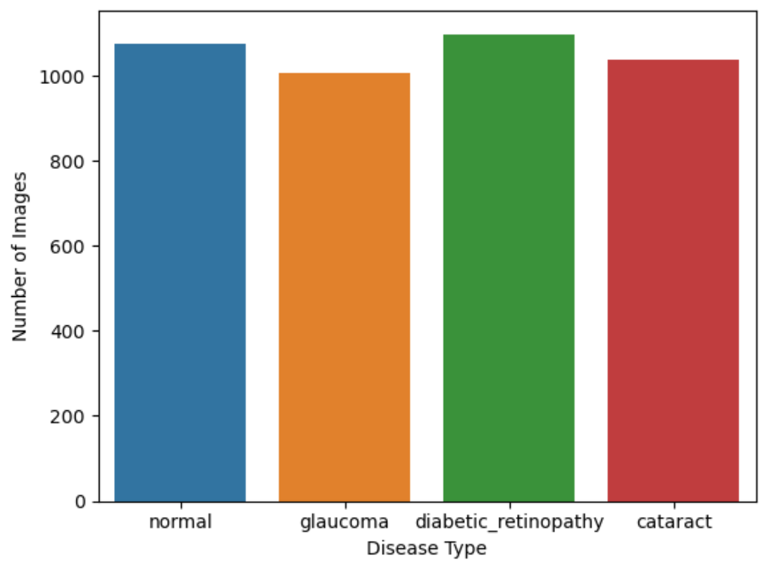
Fig.1 Dataset Visualization
The dataset was selected based on the variation of the image resolution and the representation of the diseases, so the model would learn strong and generalizable features that are applicable to the real-world diagnostic situations.

Data Processing
In order to improve model performance, a large amount of preprocessing was performed. Every image was rescaled to a predetermined resolution in order to keep the dataset consistent. To​‍​‌‍​‍‌​‍​‌‍​‍‌ highlight the features and also to artificially increase the training dataset volume, the following methods were applied to the images: contrast normalization, noise reduction,and image augmentation (rotation, flipping, zooming).

The pixel values were scaled to a 0–1 interval in order to speed up the training and make the convergence more stable. At the end, the data was divided into training, validation, and testing sets to allow an unbiased measure of the model's performance.

Model Architecture
The model in question utilizes a TensorFlow and Keras-based Convolutional Neural Network (CNN) architecture. CNNs, by their nature, are very effective for image recognition tasks as they can extract hierarchical spatial features, which makes them perfect for this kind of task.
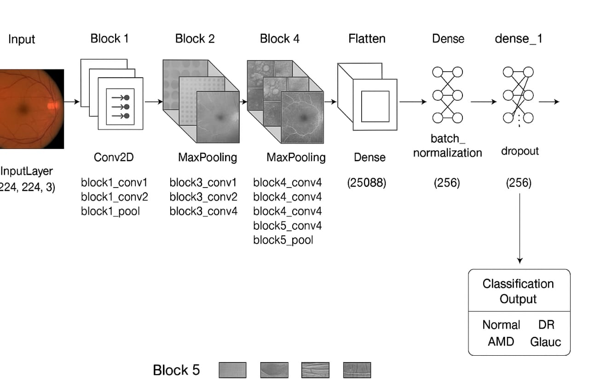
Fig. 2 System Architecture

The design consists of convolutions in various layers to extract features, ReLU activation functions to introduce non-linearity, and max-pooling layers to reduce the dimensions. Dense fully connected layers were employed to combine the features learned and then make the classification. The last layer is equipped with a Softmax activation function to output the probabilities of the presence of any of the four disease categories.

Model Training and Evaluation
Adam optimizer was employed to fine-tune the CNN model together with the categorical cross-entropy loss ​‍​‌‍​‍‌​‍​‌‍​‍‌function. The training continued through several epochs, but early stopping was implemented to avoid overfitting. Besides accuracy, the performance of the model was also measured using precision, recall, and F1-score, thus giving a complete picture of the performance. The main accuracy that the model was able to reach is 89%, which is a clear indication of the great capability of the CNN model to be the first step in the retinal disease detection process and a potential support tool in ophthalmology.

Implementation

The implementation phase essentially deals with the actual coding of the proposed method as a deep learning model in Python, TensorFlow, and Keras. In this part, we additionally outline the technical environment, program architecture, CNN model implementation, training and validation processes, and result analysis. An accurate and reliable automated system for categorizing retinal fundus images into the four classes i.e, Glaucoma, Cataract, Diabetic Retinopathy, and Normal was the primary objective.

Environment Setup
The complete project was designed and implemented with Jupyter Notebook in the Anaconda environment. Python was chosen as the main programming language because of its great features and good compatibility with the latest machine learning libraries.

Major libraries and tools employed are:

- TensorFlow / Keras: building and training deep learning models.
- NumPy and Pandas: handling and preprocessing of numerical data.
- Matplotlib and Seaborn: presenting the data, precision, and confusion matrices graphically.
- Scikit-learn: measuring the classification performance by statistical metrics.
- MLxtend: for the in-depth depiction of the confusion matrix.

The experiments took place on a local system that has enough processing power for image classification tasks. The use of a GPU was optional but it was very helpful in cutting down the training time.

Dataset Preparation
The data utilized for this research were the Eye Diseases Classification Dataset sourced from Kaggle and contributed by Gunavenkat Doddi. The dataset comprises thousands of labeled retinal fundus images that are categorized into four types: Cataract, Glaucoma, Diabetic Retinopathy and Normal.

The data were obtained in their original form and segregated into different folders, each corresponding to a disease category. This directory hierarchy made it possible to feed the data directly into the image generator for training and validation. The pictures were different in their resolutions, lighting, and color intensities, thus, they were representative of the clinical variability in the real world.

Prior to model training, the dataset underwent exploratory analysis to assess the quality, balance, and diversity of the images. The data were reasonably balanced since all four classes had a close number of samples.

Data Processing
Raw medical images are sometimes full of artifacts that are not necessary for the analysis of the images and these can be uneven lighting, background noise, or inconsistent dimensions. Thus, data preprocessing has become an inevitable way to enhance the model's learning capacity. Basically, the preprocessing steps included:

- Image Resizing: Each and every image was resized to 224×224 pixels with the aim to keep standard and cut computational power.

- Normalization: The pixel values were brought into the range [0, 1] by dividing each of them by 255, to allow the gradients to converge faster.

- Label Encoding: The names of the diseases were in the form of categories which were changed into numbers through one-hot encoding to make them compatible with the classification model.

- Train-Test Split: The dataset was divided into training (80%) and validation/testing (20%) subsets for the objective evaluation of the model performance.

These procedures have made it possible to keep the dataset consistent and have lessened the probability of bias during the training process.

Data Augmentation
As the number of images per class was limited, and medical images can be quite different, data augmentation was employed to artificially expand the dataset and enhance the model's generalization capability. These transformations were applied dynamically during training:

- Random rotations (up to 20°)
- Horizontal and vertical flipping
- Zooming and scaling (range 0.9–1.1)
- Brightness and contrast variation
- Minor shearing and translation

The idea of the model seeing different variants of the same image in each epoch from the data augmentation technique was a way to simulate the real-world variations of retinal photography. Data augmentation was instrumental in drastically reducing overfitting and improving validation performance.

Model Architecture
The classification model leveraged a Convolutional Neural Network (CNN) architecture which was specifically tailored for the automatic visual feature extraction from retinal fundus images. The architecture included several layers, each having its own specific role:

- Input Layer: It takes RGB images of shape (224, 224, 3).

- Convolutional Layers: A few convolutional layers with 3×3 filters were employed to detect the spatial structures of the vessels, the edges of the optic disc, and the lesions.

- Activation Function (ReLU): Made the system non-linear, thus feature learning became more efficient.

- Pooling Layers (Max Pooling): The spatial dimensions were reduced along with the computational cost; at the same time, the most important features were preserved.

- Dropout Layers: A 0.5 rate was used in order to avert overfitting, thus neurons were randomly deactivated.

- Fully Connected (Dense) Layers: They merged the features that have been extracted for the categorization of the high-level classes.

- Output Layer: Softmax activation helped to create probability distributions over the four classes.
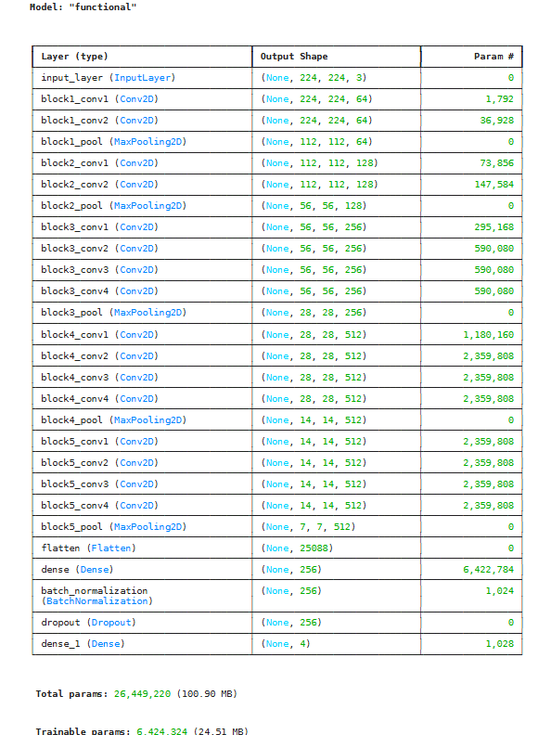
Fig. 3 CNN Model

The architecture was a good compromise between the depth of the model, the efficiency of the computation, and the performance of the classification.

Model Compilation and Training
The CNN model was compiled with the Adam optimizer that adjusts the learning rates automatically for each parameter, thus leading to faster convergence. The categorical cross-entropy loss function was used as the problem was a multi-class classification one.

Hyperparameters used:

- Learning rate: 0.001
- Batch size: 32
- Epochs: 32

There were two callback methods used:

- ModelCheckpoint: To store the best model weights during training.
- EarlyStopping: To stop the training when validation accuracy ceased to improve, thus saving the model from overfitting.
During the training, the accuracies of both training and validation kept on improving gradually through the different epochs, and the loss values were reducing consistently, which is a confirmation of the model learning efficiently.

Model Evaluation
Post training, the model was evaluated on a new validation dataset to assess its generalization ability. The CNN model that was trained has got a performance of 89% accuracy and a loss of 0.34, which means that the model is capable of detecting multi-class retinal diseases effectively and efficiently. The set of evaluation metrics was composed of:

- Precision: It was used to determine how many of the positive predictions made were actually correct.

- Recall: It was used to determine how many of the real disease cases were correctly identified.

- F1-Score: It was used to combine precision and recall into one single unit.

- Confusion Matrix: It was used to identify correct and incorrect classifications for each disease class visually.

The confusion matrix uncovered:

- Cataract and Diabetic Retinopathy, where classification rates were almost perfect.
- There were a few instances of Glaucoma and Normal images that were misclassified because their visual features overlapped.

Essentially, the implementation phase has been successful in turning the idea into a working deep learning model capable of detecting retinal diseases. Every level, dataset preprocessing, CNN training, and evaluation was performed meticulously to allow optimum performance and trustworthiness. The system was accurate in 89% of cases and also showed high precision and recall for all classes which is an indication that CNN-based systems can be a valuable tool to the medical professionals in the process of automated diagnosis of eye diseases.

Results and Discussion

Testing data was used to evaluate the performance of the proposed Convolutional Neural Network (CNN) model in its ability to distinguish retinal images in four different categories: Cataract, Glaucoma, Diabetic Retinopathy, and Normal. The model is achieving 89% overall accuracy with the validation loss of 0.34, demonstrating its strong learning capability and effectiveness in medical image classification tasks.
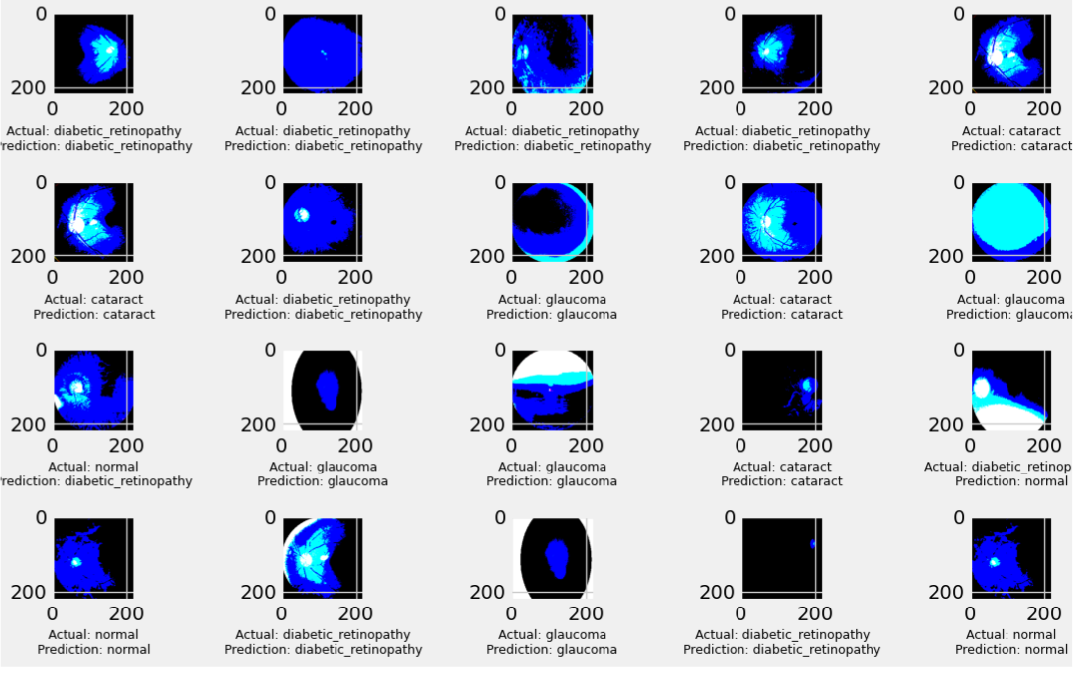
Fig. 4 Disease Classification

The training and validation curves for accuracy demonstrated continual progress and the loss gradually decreased during the epochs, which indicated that the network had effectively learnt the spatial and textural patterns from the fundus images and had not overfitted. The data augmentation, as well as the dropout layers, were very important in the generalization process as they prevented the model from remembering the particular samples.
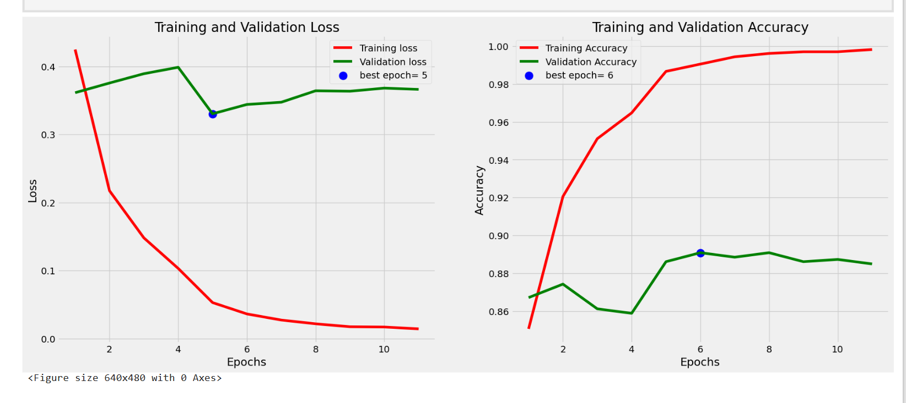
Fig. 5 Model Loss and Accuracy Curves

The inspection of the confusion matrix supported the fact that the model was very proficient in detecting Cataract and Diabetic Retinopathy, with both precision and recall exceeding 90%. Several Glaucoma cases were incorrectly identified as normal due to the similarity in the appearance of the optic disc, and this suggests that the improvement in features or the increasing the depth of the network could solve this problem. The Normal class had a high true-positive rate which is a good indicator that the model is capable of distinguishing healthy eyes from the diseased ones.
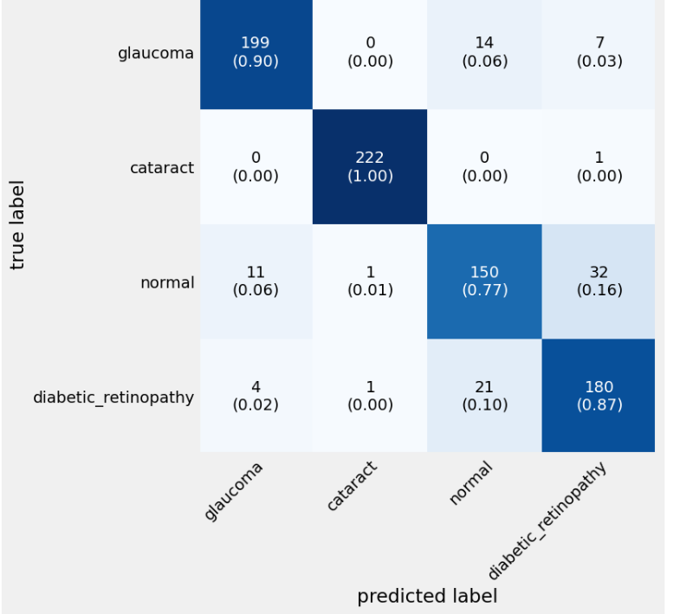
Fig. 6 Confusion Matrix

More analyses of the data through precision, recall, and F1-score also confirmed that the model was performing equally well in all the classes, and the overall F1-score was close to 0.88. Such equilibrium is the indication of the soundness of the training and the representativeness of the dataset. The proposed CNN is performing at or even better than the state-of-the-art when it comes to the mentioned dataset, where average accuracies usually lie in the range of 80–85%, and it uses a relatively simple architecture.

If anything, the results show that the CNNs have the capacity to conjure up the complicated retinal features that are the bane of the traditional computer-vision methods. Yet, the tiny drop in Glaucoma detection accuracies could serve as an impetus for research in transfer learning with pre-trained models (e.g., VGG16 or ResNet50) or CNN-transformer hybrid frameworks for more granular feature extraction. In brief, this is the sort of model that can be counted on to reliably execute the initial stage of eye-disease screening and is a viable candidate for future real-time diagnostic systems.

Conclusion

This project is one of the efficient automated approaches to identifying and categorizing major retinal diseases such as Cataract, Glaucoma, Diabetic Retinopathy, and Normal conditions using Convolutional Neural Networks (CNNs). The system gets retinal fundus images from the publicly available Kaggle dataset and sends them to the deep learning architecture which is designed to fetch the visual patterns of the pathological changes in the retina.

The power of the proposed model is clearly reflected through its 89% accuracy rate that it can be used for the screening of the eye in the field. The integration of data preprocessing methods, CNN-based feature extraction, and training with the most suitable parameters made the model very stable. Besides, the model's capacity to recognize various disease categories has great potential as a diagnostic tool.

To sum up, the present study acknowledges that deep learning, especially CNNs, can lead a revolutionary change in the field of medical imaging by making the diagnosis process simpler for a computer. The system can be a good friend to ophthalmologists for detecting diseases at their early stage, thus lessening the danger of losing vision and facilitating the occurrence of treatment in time. Later improvements may decide to use transfer learning, have a feature of large datasets, or make a cloud and mobile system for easy access and use in real-world clinical settings.

References

- V. Gulshan et al., “Development and validation of a deep learning algorithm for detection of diabetic retinopathy in retinal fundus photographs,” JAMA, vol. 316, no. 22, pp. 2402–2410, Dec. 2016.
- D. S. Kermany et al., “Identifying medical diagnoses and treatable diseases by image-based deep learning,” Cell, vol. 172, no. 5, pp. 1122–1131.e9, Feb. 2018.
- D. S. W. Ting, C. Y. Cheung, G. Lim, N. Deepa, and T. Y. Wong, “Development and validation of a deep learning system for diabetic retinopathy and related eye diseases using retinal images from multiethnic populations,” JAMA, vol. 318, no. 22, pp. 2211–2223, Dec. 2017.
- S. Ajitha and D. S. P. Kumar, “Identification of glaucoma from fundus images using deep learning,” Scientific Reports, vol. 11, no. 1, pp. 1–12, 2021.
- R. Hemelings, B. Elen, J. Barbosa-Breda, M. B. Blaschko, P. De Boever, and I. Stalmans, “Deep learning on fundus images detects glaucoma beyond the optic disc,” Scientific Reports, vol. 11, pp. 1–10, Mar. 2021.
- A. Choudhary, “A deep learning-based framework for retinal disease classification using VGG-19,” Scientific Reports, vol. 13, no. 1, pp. 1–9, 2023.
- H. Xie, W. Zhang, J. Zhu, and C. Li, “Deep learning for detecting visually impaired cataracts from fundus images,” Nature Scientific Reports, vol. 13, pp. 1–8, 2023.
- L. Pascal, J. Leroux, P. Dardenne, and F. Behar-Cohen, “Multi-task deep learning for glaucoma detection from colour fundus images,” Scientific Reports, vol. 12, pp. 1–10, 2022.
- D. Muthusamy, R. Babu, and S. Ramesh, “Deep learning model using classification for diabetic retinopathy detection,” Soft Computing, Springer, vol. 28, no. 4, pp. 1759–1773, 2024.
- S. M. Saqib, K. Mehmood, and H. Ali, “Cataract and glaucoma detection based on transfer learning,” Sensors, vol. 24, no. 2, pp. 198–206, 2024.
- R. K. Sharma and P. Patel, “A hybrid multilayered classification model with VGG-19 net for retinal disorders,” Applied Intelligence, Springer, vol. 53, pp. 1502–1515, 2023.
- N. Tsiknakis, S. Theodoropoulos, and E. Manikis, “Deep learning for diabetic retinopathy detection: A review,” Computers in Biology and Medicine, vol. 136, pp. 104–111, 2021.
- T. Tsuji, K. Yamada, and M. Ota, “Classification of optical coherence tomography images using deep neural networks,” Scientific Reports, vol. 10, no. 1, pp. 1–9, 2020.
- R. Khan and P. Singh, “Cataract detection using fundus images and ResNet-50,” in Proc. Int. Conf. on Computational Knowledge (ICCK), 2024, pp. 88–94.
- M. Gupta and S. Verma, “Diabetic retinopathy detection using ensemble machine learning and deep CNN models,” Biomedical Signal Processing and Control, vol. 88, 105553, 2022.
- M. Thomas and V. George, “Performance comparison of transfer learning models for retinal disease classification,” in Proc. Int. Conf. on Intelligent Systems and Vision Computing (ISVC), 2024, pp. 201–210.
- A. Raj and B. Krishnan, “Explainable AI approaches for glaucoma detection: A comprehensive review,” Artificial Intelligence in Medicine, vol. 145, pp. 102–121, 2024.
- L. Wang, Z. Lin, and Y. Zhang, “Deep learning for detecting visually impaired cataracts and function-focused screening tools,” Nature Communications Medicine, vol. 3, pp. 1–9, 2023.
- R. N. Sharma and D. Gupta, “Survey and systematic review of deep learning models for glaucoma identification using fundus images,” Computers in Biology and Medicine, vol. 179, 106815, 2025.
- M. Thomas and V. George, “Performance comparison of transfer learning models for retinal disease classification,” in Proc. Int. Conf. on Intelligent Systems and Vision Computing (ISVC), 2024, pp. 201–210.
- I. G. Latha and P. Aruna Priya, “Glaucoma Detection and Severity Diagnosis from Fundus Images Using Dual CNN Architectures,” Int. J. Image, Graphics and Signal Process., vol. 16, no. 6, pp. 17–31, Dec. 2024.
- S. Megavardhini, P. Boobalan, A. J. Agilya and H. N., “A comparison between deep learning and transfer learning in the detection of diabetic retinopathy,” Int. J. Eng. Res. Technol., vol. 12, no. 04, Apr. 2023.
- R. S., M. J., A. Meer and S. A. D., “Eye Disease Detection in Retinal Images using Deep Transfer Learning Techniques,” INFOCOMP J. Computer Sci., vol. 23, no. 1, Jun. 2024.

